**Ex 9 :**

**ListofPlayers.js**

import React from 'react';

const ListofPlayers = () => {

  const players = [

    { name: 'Rohit', score: 85 },

    { name: 'Gill', score: 45 },

    { name: 'Kohli', score: 95 },

    { name: 'Rahul', score: 30 },

    { name: 'Iyer', score: 77 },

    { name: 'Pandya', score: 60 },

    { name: 'Jadeja', score: 35 },

    { name: 'Ashwin', score: 68 },

    { name: 'Bumrah', score: 90 },

    { name: 'Shami', score: 40 },

    { name: 'Kuldeep', score: 50 }

  ];

  const below70 = players.filter(player => player.score < 70); // Arrow function

  return (

    <div>

      <h2>All Players</h2>

      {players.map((player, index) => (

        <p key={index}>{player.name} - {player.score}</p>

      ))}

      <h3>Players with Score Below 70</h3>

      {below70.map((player, index) => (

        <p key={index}>{player.name} - {player.score}</p>

      ))}

    </div>

  );

};

export default ListofPlayers;

**IndianPlayers.js**

import React from 'react';

const IndianPlayers = () => {

  const teamPlayers = ["Player1", "Player2", "Player3", "Player4", "Player5", "Player6"];

  // Destructuring the array

  const [odd1, even1, odd2, even2, odd3, even3] = teamPlayers;

  const T20players = ['Rohit', 'Kohli', 'Bumrah'];

  const RanjiPlayers = ['Jaiswal', 'Sarfaraz', 'Unadkat'];

  // Merging using spread operator

  const allPlayers = [...T20players, ...RanjiPlayers];

  return (

    <div>

      <h2>Odd Team Players</h2>

      <ul>

        <li>{odd1}</li>

        <li>{odd2}</li>

        <li>{odd3}</li>

      </ul>

      <h2>Even Team Players</h2>

      <ul>

        <li>{even1}</li>

        <li>{even2}</li>

        <li>{even3}</li>

      </ul>

      <h2>Merged T20 + Ranji Players</h2>

      <ul>

        {allPlayers.map((player, index) => <li key={index}>{player}</li>)}

      </ul>

    </div>

  );

};

export default IndianPlayers;

**App.js**

import React from 'react';

import './App.css';

import ListofPlayers from './components/ListofPlayers';

import IndianPlayers from './components/IndianPlayers';

function App() {

  const flag = false;

// Set to false to show IndianPlayers component instead

  return (

    <div className="App">

      <h1>🏏 Cricket App</h1>

      {flag ? <ListofPlayers /> : <IndianPlayers />}

    </div>

  );

}

export default App;

**App.js**

import React from 'react';

import './App.css';

import ListofPlayers from './components/ListofPlayers';

import IndianPlayers from './components/IndianPlayers';

function App() {

  const flag = true;

// Set to false to show IndianPlayers component instead

  return (

    <div className="App">

      <h1>🏏 Cricket App</h1>

      {flag ? <ListofPlayers /> : <IndianPlayers />}

    </div>

  );

}

export default App;

**Output :**

Flag = true

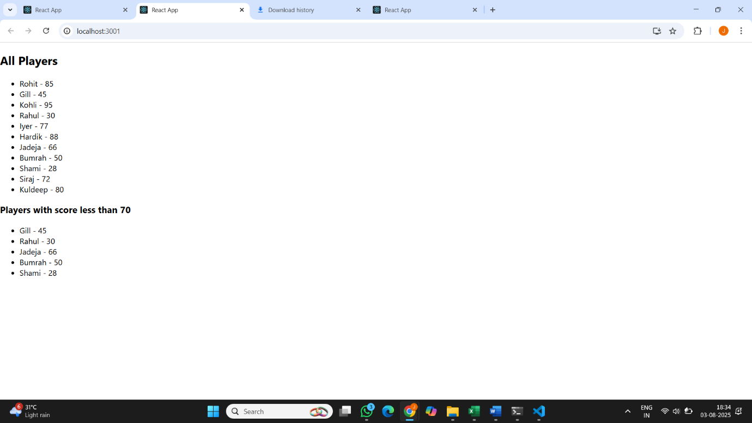

Flag = false

